VA New Hampshire Vision 2025 Task Force – Stakeholder Meetings - October 3, 2017

Purpose: provide an introduction of the taskforce members, review taskforce charge, work plan, and communications plan. An opportunity will be provided for feedback related to the communications plan and for questions and answers. This session is distinct from the focus groups which are being held to gather specific stakeholder input as part of the Task Force's work.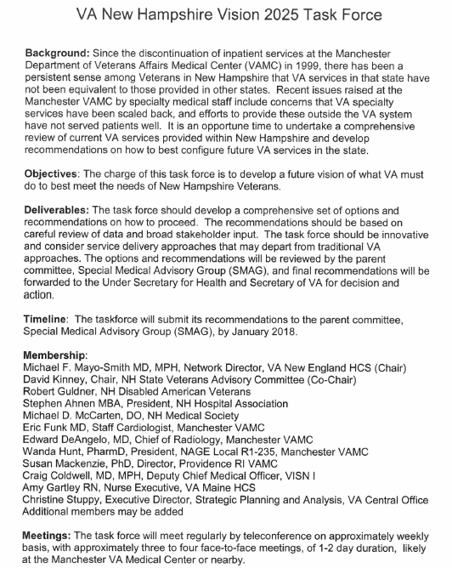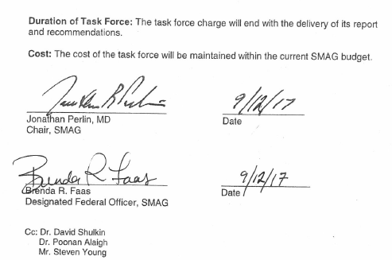
VA New Hampshire Vision 2025 Task Force

Guiding Principles:
- The task force is guided by what is best for New Hampshire’s Veterans.
- All options are on the table.
- This task force will be data driven.
- The task force will be soliciting broad input from stakeholders.
- Recommendations will address how we can deliver full services to Veterans in NH, commensurate with VA services in other states.
- The task force will provide regular updates to stakeholders to ensure they are well informed.

Work Plan:

- Review past, present and projected demographic and workload data.
- Obtain and analyze broad stakeholder input
- Discuss and evaluate analyses from seven Clinical Service Lines (Primary Care, Geriatrics and Extended Care, Mental Health, Rehabilitation, Medicine, Surgery and Radiology).
- Examine Community Market Survey (from Office of Policy and Planning).
- Review infrastructure analysis from VHACO and architectural consultant
- Develop options for consideration, including estimates of staffing, space needs and infrastructure implications
- Formulate recommendations from Task Force regarding the options to the Special Medical Advisory Group by January 2018
- Finalization of recommendations by Special Medical Advisory Group to be sent to Secretary of VA

Task Force Website:

- Website: www.newengland.va.gov/nhvision
- Background information and ongoing updates
- Opportunity for input from all individuals and groups (coming soon)
- Opportunity for questions and FAQs (coming soon)

